|  |  |  |
| --- | --- | --- |
|  | RESEARCH AND TESTING CENTER FOR THERMAL SOLAR SYSTEMS  **Institute for Thermodynamics and Thermal Engineering  University of Stuttgart** | in cooperation with |

**Final report on**

**Annual output indicator for solar water heater stores**

**(*Acronym: DHW-Store-Indicator)***

Project: 4C02b-DHW-Store-Indicator_ITW

SCF-Call No. 4

27th September, 2013

Version 1.0

|  |  |
| --- | --- |
| Participant 1: | Dr.- Ing. Stephan Fischer  Pfaffenwaldring 6, 70550 Stuttgart, Germany  fischer@itw.uni-stuttgart.de |
| Participant 2: | Dipl.- Ing. Stephan Bachmann  Pfaffenwaldring 6, 70550 Stuttgart, Germany  bachmann@itw.uni-stuttgart.de |
|  |  |

Institut für Thermodynamik und Wärmetechnik (ITW) • Pfaffenwaldring 6 • 70550 Stuttgart

Tel. 0049(0)711/685-63536 • Fax 0049(0)711/685-63503 • e-mail: tzs@itw.uni-stuttgart.de

**Contents**

1. Introduction 3

2. Comparison of stores 3

3. Determination of the “hot water volume” Cu according to EN 15332:2007 3

4. Annual system simulation 5

5. Application of the method for three different DHW stores 6

5.1 Alternative method 10

5.2 Results for stores with a nominal volume of 500 litres 11

6. Summary 14

Appendix A: 15

A1 Influence of the location 15

A2 Influence of the store volume 15

1. **Introduction**

In order to calculate an annual output indicator for solar water heater stores, which takes into account all store parameters (volume, heat loss rate, stratification number, effective vertical thermal conductivity, heat transfer capacity rate of the immersed exchangers and their capability of stratification) an annual system simulation under reference conditions is required. By doing this e. g. the fractional energy savings fsav can be used for the assessment of these stores. Since the fractional energy savings depend strongly on the auxiliary volume and the temperature level of this volume an additional parameter has to be taken into account which describes the ability of the store for performing hot water if there is no solar energy input. This can be done by the determination of the “hot water volume” Cu according to EN 15332:2007.

1. **Comparison of stores**

The comparison of stores using fsav is only reasonable if they have nearly the same capacity (same class of stores). To define a class of stores it is suggested to use the nominal volume VN stated by the manufacturer. Furthermore it is required that the stores which shall be compared provide the same “hot water volume” Cu. For the determination of an annual output indicator it is recommended that this volume is half of the nominal volume VN of the store. Since the useful thermal capacity of the auxiliary volume of the store is fixed by the position of the auxiliary heat exchanger and the temperature sensor the “hot water volume” Cu can be adapted by changing the set temperature of the auxiliary heater. So the method for the determination of the annual output indicator of DHW stores has to be performed by 3 steps:

1. Testing of the store according to EN 12977-3:2012
2. Adaption of the set temperature for the auxiliary heater and determination of the “hot water volume” Cu according to EN 15332:2007
3. Performing of an annual system simulation under reference conditions using the determined set temperature gained in step 2.

Then the result of the annual system simulation (fsav) can be used as a store indicator for this class of stores. Of course fsav of different classes of stores cannot be compared.

1. **Determination of the “hot water volume” Cu according to EN 15332:2007**

The standard EN 15332 describes a method for the determination of the “hot water volume” Cu which can be tapped at a usable temperature for conventional hot water stores. This parameter can be used for solar water heater stores to assess their ability for providing hot water. Figure 1 shows the test sequence according to EN 15332.

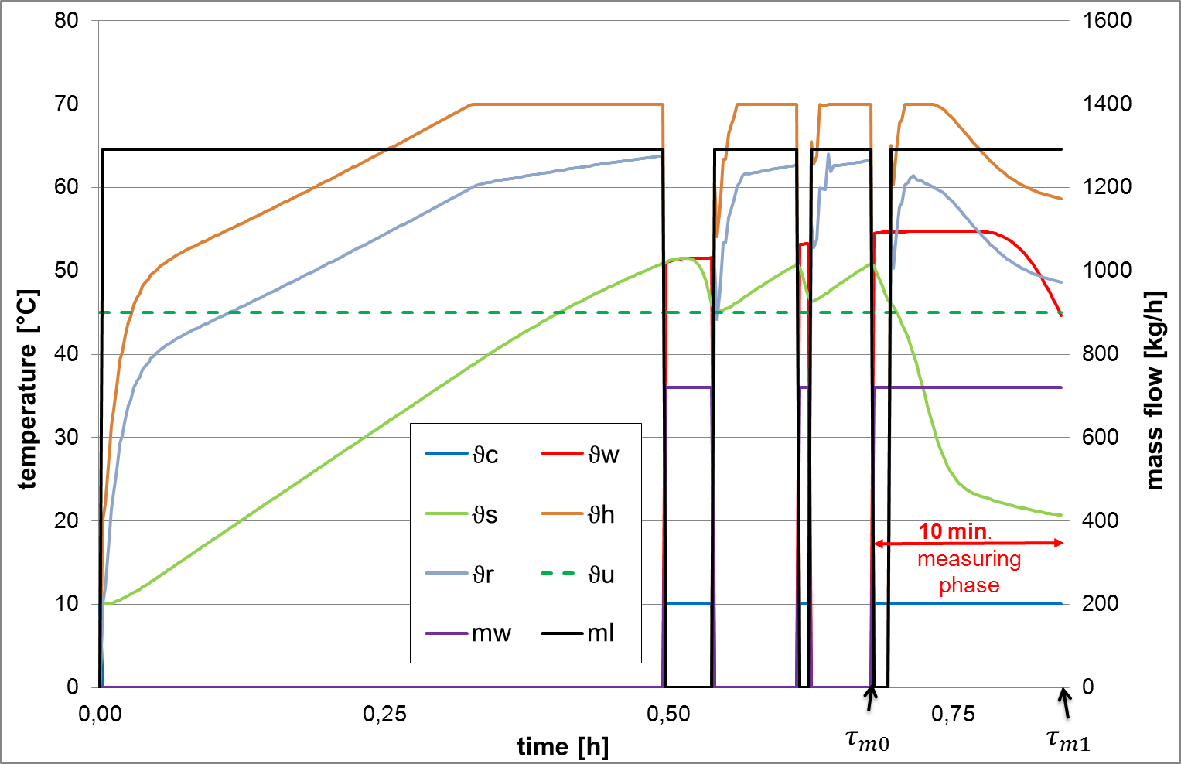

**Figure 1:** Test sequence according to EN 15332 with: ϑc = cold water temperature, ϑw = hot water temperature, ϑs = store temperature at the sensor for the auxiliary heater, ϑh = flow temperature of the auxiliary heater, ϑr = return temperature of the auxiliary heater, ϑu = minimum usable hot water temperature, mw = mass flow hot water, ml = mass flow auxiliary heater (abbreviations according to EN 15332)

The store is charged and discharged alternately for 3 times. During the last discharge phase (measuring phase) the store is charged simultaneously if the temperature at the sensor for the auxiliary heater falls below the switch-on temperature. The hot water mass flow rate has to be adapted so that the hot water temperature falls below the usable temperature (45 °C) after 10 minutes (duration of the measuring phase). Since it is not allowed to change the hot water mass flow rate during the whole test sequence this task has to be solved iteratively.

Boundary conditions according to EN 15332:

* $ϑ_{c}$ = 10 °C
* $ϑ_{w,max}$ = 65 °C
* $ϑ_{u}$ = 45 °C
* $ϑ_{h,max}$ = 70 °C
* measuring phase = (10±1) min.

The “hot water volume” Cu is calculated according to equation 1:

$C_{u }=\sum_{τ_{m0}}^{τ_{m1}}{V_{w }* ∆τ* \frac{(ϑ_{w}- ϑ_{c})}{(ϑ_{u}-10 °C)}}$ (1)

with (abbreviations according to EN 15332):

* $τ_{m0}$ = begin of measuring phase [h]
* $τ_{m1}$ = end of measuring phase [h]
* $∆τ$ = sampling interval [s] (max. 10 s)
* Vw = hot water volume flow rate [l/h]

Additional boundary conditions with regard to DHW-Store-Indicator:

* Power of the auxiliary heater Paux [kW] = VN [l] / 20 [l]/[kW]
* ΔTaux = 5 K

According to EN 15332 this test sequence has to be performed using an appropriate test facility. But it is also possible to use a mathematic model for the store (e. g. TRNSYS Type 340) to determine Cu. This store model is needed anyway for the annual system simulation to determine the fractional energy savings fsav. The advantage using a model is that it takes less time to perform the test. Therefore it is possible to adjust the hot water volume flow rate much more closely than at the test facility to fulfil the 10 min.-criteria of the measuring phase. The tolerance of ±1 min can be underrun easily which leads to better results. Therefore it is suggested to determin Cu by simulation.

Using this method the “hot water volume” Cu can be determined for a default switch temperature of the auxiliary heater. Since different stores often differ in the auxiliary volume (fixed by the position of the auxiliary heat exchanger) even if they have nearly the same volume (same nominal volume VN) the set temperature of the auxiliary heater has to be adapted so that the stores provide the same “hot water volume” Cu. It is possible and recommended to adjust the set temperature until the required “hot water volume” Cu is reached with a deviation of max. ±2 %.

1. **Annual system simulation**

After the adjustment of the set temperature for the auxiliary heater the annual system simulation can be performed. For a reasonable comparison of stores the following reference conditions according to EN 12977-2:2012 are suggested:

* weather: TRY Würzburg according to EN 12977-2:2012
* daily hot water load according to EN 12977-2:2012, table A.1, which is closest to 2/3∙VN, example: VN = 400 l → Vd’ = 2/3∙400 l = 266,7 l → **Vd = 250 l is chosen**
* if the manufacturer indicates a nominal volume which is not rounded, the value has to be rounded to the next complete 10 litres (e. g. instead of 305 litres the nominal volume of 310 litres should be used, or 300 litres instead of 304 litres)
* required hot water volume Cu: half of nominal volume
* collector area: VN / 60 l/m2
* parameters for auxiliary heating according to chapter 3 of this document
* collector orientation, collector tilt angle, pipe diameter and insulation thickness of collector circuit, store ambient air temperature, mains water supply temperature, desired hot water temperature and draw-off flow rate according to EN 12977-2:2012, table A.1
* collector loop mass flow rate: 40 kg/(m2∙h)
* switch-on/ switch off-temperature difference of collector loop pump: 10 K / 5 K, max. store temperature: 90 °C
* if the solar loop heat exchanger is equipped with a device for thermal stratification the control strategy concerning the volume flow rate and the temperature differences recommended by the manufacturer has to be implemented

As parameters for the collector the following “standard parameters” of a flat plate collector are recommended:

* Ƞ0 = 0,80
* a1 = 3,5 W/(m2∙K)
* a2 = 0,02 W/(m2∙K2)
* Ceff = 7,0 kJ/(m2∙K)
* b0 = 0,18
* IAMdfu = 0,89

1. **Application of the method for three different DHW stores**

Figure 2 to figure 4 show the tested DHW stores W300, B300 and S300. All stores have a nominal volume VN of 300 litres. The stores differ in some details: The stores W300 and B300 are made from steel and they are equipped with removable flexible foam. The store S300 is made from stainless steel foamed in with PU foam. Only the collector loop heat exchanger of store B300 is equipped with a device for stratified charging. The auxiliary flow rate of store W300 runs from the bottom to the top (recommended by the manufacturer). For the other stores the flow direction is vice versa.



Figure 2: DHW store W300



Figure 3: DHW store B300



Figure 4: DHW store S300

Table 1 shows the parameters of the stores derived from tests according to EN 12977-3:2012, the determined set temperature for the auxiliary heater according to chapter 3 and the fractional energy savings fsav according to equation 2 determined under conditions described in chapter 4.

 2

with:

|  |  |
| --- | --- |
| Qconv,net | heat demand of a conventional heating system (without solar) [kWh/a] |
| Qaux,net | auxiliary heat demand of the solar domestic hot water system [kWh/a] |

|  |  |  |  |
| --- | --- | --- | --- |
| **Parameters\ Store** | **W300** | **B300** | **S300** |
| Nominal volume [l] | 300 | | |
| required hot water volume Cu [l] | 150 | | |
| Determined hot water volume Cu [l] | 150,3 | 149,4 | 150,4 |
| Total usable volume of the store with HX [l] | **336,3** | **305,9** | **276,6** |
| Heat loss rate [W/K] | 2,59 | 2,30 | 2,17 |
| Effective thermal conductivity [W/Km] | 1,81 | 1,76 | 0,64 |
| Rel. height inlet cold water [%] | 0 | 0 | 0 |
| Rel. height outlet hot water [%] | 100 | 100 | **94** |
| Number of nodes for the store [-] | 108 | 111 | 163 |
| **Collector loop:** | | | |
| Solar volume inclusive solar-HX [l] | 198,4 | 174,4 | 154,9 |
| Rel. height connection of collector flow [%] | 43 | 94 | **7[1]** |
| Rel. height connection of collector return [%] | 0 | 0 | 561 |
| Rel. height of store temp. sensor [%] | 9 | 6 | 32 |
| mass flow rate [kg/h] | 200 | 60 - 200 | 200 |
| Pipe inside diameter [mm] | 13 | | |
| Device for thermal stratification | no | yes | no |
| **Auxiliary heating:** | | | |
| Auxiliary volume exclusive HX volume [l] | **131,9** | **124,0** | **121,7** |
| Auxiliary set (switch on) temperature [°C] | **46,0** | **49,5** | **55,5** |
| direction of flow | bottom - top | top - bottom | top - bottom |
| Relative position of aux. temp. sensor [%] | 70 | 71 | 72 |
| Relative position of aux. inlet [%] | 59 | 77 | 86 |
| Relative position of aux. outlet [%] | 85 | 57 | 56 |
| Power of auxiliary heater [kW] | 15 | | |
| Mass flow rate [kg/h] | 1292,0 | | |
| Max. flow temperature [°C] | 70 | | |
| **fsav [%]** | **62,0** | **59,1** | **56,8** |

Table 1: Store parameters and results for fsav

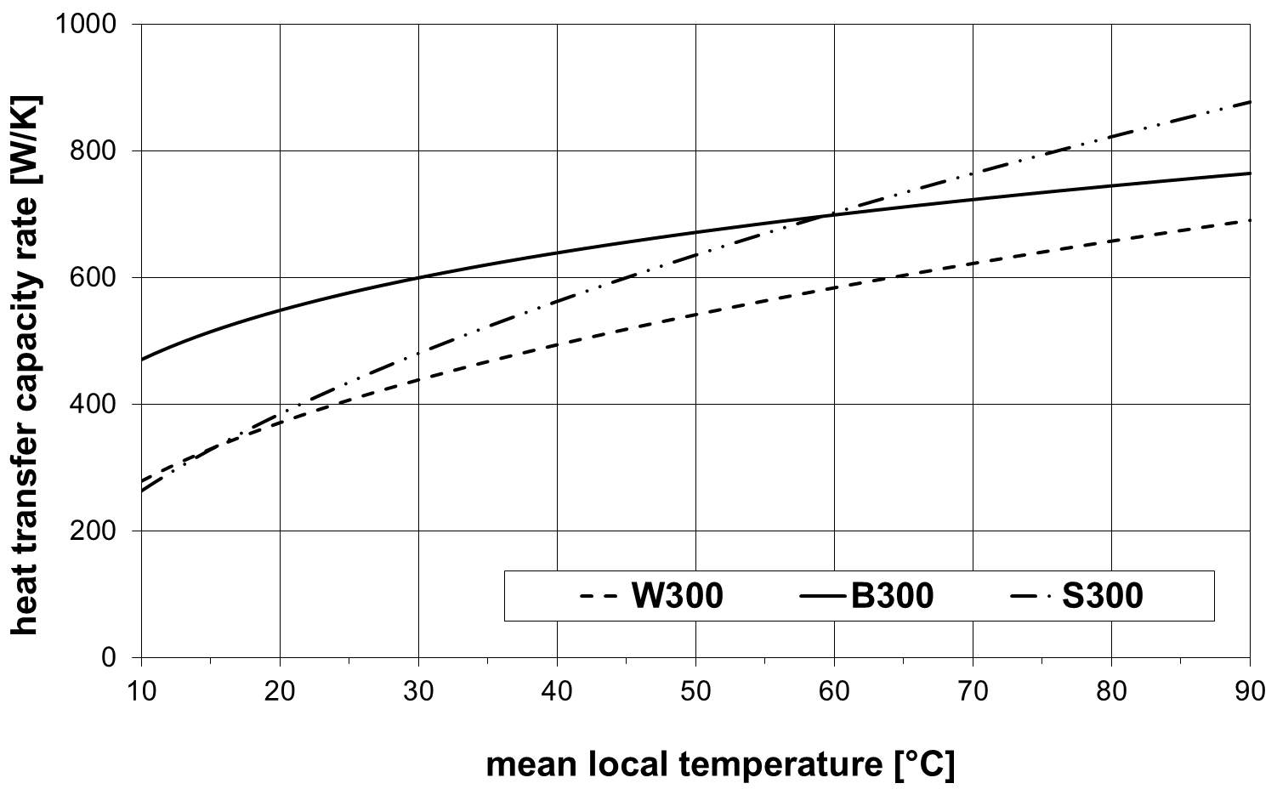

Figure 5: Heat capacity rate of the auxiliary heat exchangers (volume flow rate 1290 /h)

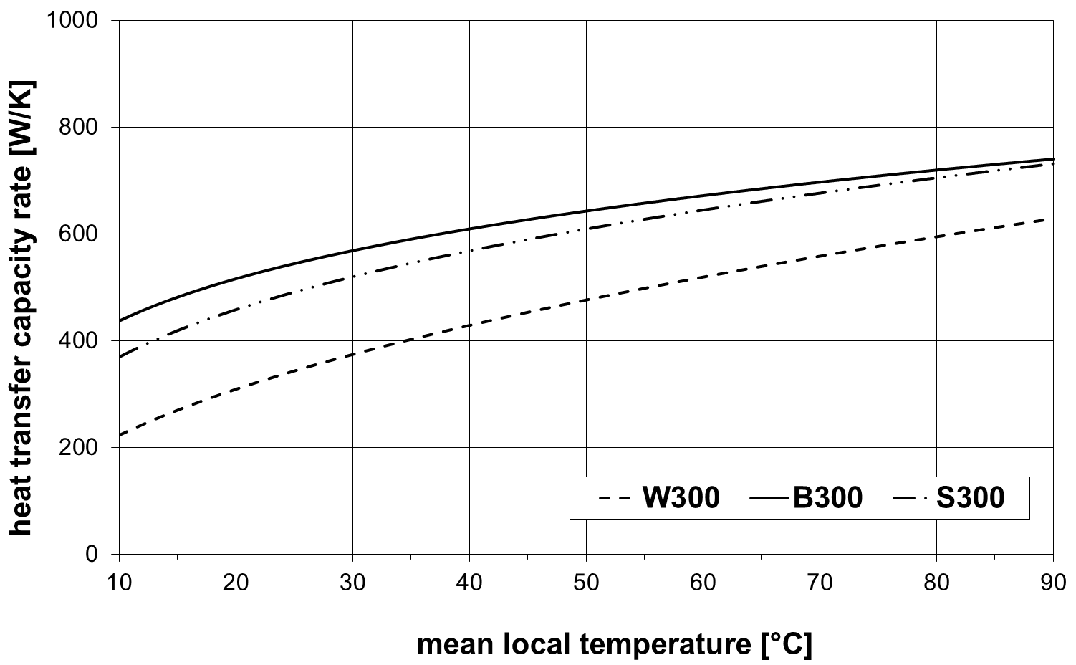

Figure 6: Heat capacity rate of the solar loop heat exchangers (volume flow rate 200 /h)

Table 1 shows, that the store W300 needs the lowest set temperature to achieve a “hot water volume” Cu of 150 l the heat capacity rate of the auxiliary heat exchanger is the lowest (see figure 5). The reason therefor is the largest auxiliary volume and the position of the temperature sensor for the auxiliary heater. The relative distance between the inlet connection of the auxiliary heater and the sensor is 15 %, at store B300 it is only 6 %. Due to this the auxiliary heater for store B300 is switched of earlier than for store W300. This has to be compensated by a higher set temperature. Simulations for store W300 have shown, that the flow direction through the auxiliary heat exchanger has very little impact on the “hot water volume” Cu. The set temperature for store S300 is the highest, due to the large death volume on top of the store (relative height of outlet for hot water: 94 %) and the smallest auxiliary hot water volume.

The store W300 achieves the highest fractional energy savings fsav although the heat loss rate of this store is the highest and the heat transfer capacity rates of the heat exchangers are the lowest. The reason therefor is shown in table 2 (results of the annual system simulations). The heat losses of the store W300 are almost the same as for the store B300, because the auxiliary set temperature for store W300 is lower as for store B300. Furthermore the collector energy gain at the heat exchanger of store W300 is the highest of all stores. This is because the solar volume of the store is the largest of all stores and the set temperature of the auxiliary volume is the lowest of all stores.

|  |  |  |  |
| --- | --- | --- | --- |
|  | W300 | B300 | S300 |
| Heat losses of store [kWh/a] | 555 | 557 | 492 |
| Heat losses of collector loop [kWh/a] | 260 | 289 | 277 |
| Collector energy gain at HX [kWh/a] | 2115 | 2039 | 1892 |
| Auxiliary heat demand [kWh/a] | 1392 | 1469 | 1552 |
| **fsav [%]** | **62,0** | **59,1** | **56,8** |

Table 2: Results of the annual system simulations

* 1. **Alternative method**

As an alternative method to specify the store indicator it is possible to use fsav and Cu as two independent parameters. In this case the hot water volume Cu and the fractional energy savings fsav can be determined with the same set temperature for all stores (e. g. 52,5 °C according to EN 12977-2:2012). Table 3 shows the results for this case. (The bold printed values are different from the ones in table 1).

|  |  |  |  |
| --- | --- | --- | --- |
| **Parameters\ Store** | **W300** | **B300** | **S300** |
| Nominal volume [l] | 300 | | |
| required hot water volume Cu [l] | **none** | | |
| Determined hot water volume Cu [l] | **175,4** | **162,5** | **140,1** |
| Total usable volume of the store [l] | 336,3 | 305,9 | 276,6 |
| Heat loss rate [W/K] | 2,59 | 2,30 | 2,17 |
| Effective thermal conductivity [W/Km] | 1,81 | 1,76 | 0,64 |
| Rel. height inlet cold water [%] | 0 | 0 | 0 |
| Rel. height outlet hot water [%] | 100 | 100 | 94 |
| Number of nodes for the store [-] | 108 | 111 | 163 |

|  |  |  |  |
| --- | --- | --- | --- |
| **Parameters\ Store** | **W300** | **B300** | **S300** |
| **Collector loop:** | | | |
| Solar volume inclusive solar-HX [l] | 198,4 | 174,4 | 154,9 |
| Rel. height connection of collector flow [%] | 43 | 94 | **7[2]** |
| Rel. height connection of collector return [%] | 0 | 0 | 561 |
| Rel. height of store temp. sensor [%] | 9 | 6 | 32 |
| Max. mass flow rate [kg/h] | 200 | | |
| Pipe inside diameter [mm] | 13 | | |
| Device for thermal stratification | no | yes | no |
| **Auxiliary heating:** | | | |
| Auxiliary volume exclusive HX volume [l] | 131,9 | 124,0 | 121,7 |
| Auxiliary set (switch on) temperature [°C] | **52,5** | | |
| direction of flow | bottom - top | top - bottom | top - bottom |
| Relative position of aux. temp. sensor [%] | 70 | 71 | 72 |
| Relative position of aux. inlet [%] | 85 | 77 | 86 |
| Relative position of aux. outlet [%] | 59 | 57 | 56 |
| Power of auxiliary heater [kW] | 15 | | |
| Mass flow rate [kg/h] | 1292,0 | | |
| Max. flow temperature [°C] | 70 | | |
| **fsav [%]** | **58,0** | **57,6** | **58,3** |

Table 3: Store parameters and results for fsav for Tset = 52,5 °C

Table 3 shows, that the fractional energy savings fsav are almost the same for all stores, but there is a great difference regarding the hot water volume Cu. It becomes apparent, that the fractional energy savings fsav can only be assessed if the hot water volume Cu is considered. Although it is important to know, that the influence of the auxiliary set temperature on fsav is much higher than on Cu.

* 1. **Results for stores with a nominal volume of 500 litres**

Table 4 shows the parameters of the stores W500 and B500 (identical in construction with the stores W300 and B300) and store V500 (see figure 7) derived from tests according to EN 12977-3:2012. Besides the determined set temperature for the auxiliary heater according to chapter 3 and the fractional energy savings fsav determined under conditions described in chapter 4 are shown.

|  |  |  |  |
| --- | --- | --- | --- |
| **Parameters\ Store** | **W500** | **B500** | **V500** |
| Nominal volume [l] | 500 | | |
| required hot water volume Cu [l] | 250 | | |
| Determined hot water volume Cu [l] | 250,9 | 249,0 | 246,0 |
| Total usable volume of the store with HX [l] | **524,8** | **504,8** | **486,8** |
| Heat loss rate [W/K] | 3,29 | 3,22 | 3,47 |
| Effective thermal conductivity [W/Km] | 1,90 | 2,03 | 1,38 |
| Rel. height inlet cold water [%] | 0 | 0 | 0 |
| Rel. height outlet hot water [%] | 100 | 100 | 100 |
| Number of nodes for the store [-] | 174 | 167 | 151 |
| **Parameters\ Store** | **W500** | **B500** | **V500** |
| **Collector loop:** | | | |
| Solar volume inclusive solar-HX [l] | 304,4 | 282,7 | 264,8 |
| Rel. height connection of collector flow [%] | 51 | 94 | 49 |
| Rel. height connection of collector return [%] | 0 | 0 | 8 |
| Rel. height of store temp. sensor [%] | 9 | 6 | 14 |
| mass flow rate [kg/h] | 333,3 | 100–333,3 | 333,3 |
| Pipe inside diameter [mm] | 16 | | |
| Device for thermal stratification | no | yes | No |
| **Auxiliary heating:** | | | |
| Auxiliary volume exclusive HX volume [l] | **211,4** | **214,6** | **213,7** |
| Auxiliary set (switch on) temperature [°C] | **47,5** | **43,0** | **53,0** |
| direction of flow | bottom - top | top - bottom | |
| Relative position of aux. temp. sensor [%] | 71 | 61 | 80 |
| Relative position of aux. inlet [%] | 58 | 75 | 82 |
| Relative position of aux. outlet [%] | 86 | 56 | 58 |
| Power of auxiliary heater [kW] | 25 | | |
| Mass flow rate [kg/h] | 2153,0 | | |
| Max. flow temperature [°C] | 70 | | |
| **fsav [%]** | **61,9** | **61,2** | **60,5** |

Table 4: Store parameters and results for fsav



Figure 7: Store V500

Table 4 shows that the store B500 needs a lower set temperature to achieve a “hot water volume” Cu of 250 l compared to store W500 despite of a lower heat transfer capacity rate of the auxiliary heat exchanger (see figure 8). The reason therefore is the height of the temperature sensor for the auxiliary heater which is lower as it is for store W500. Nevertheless the fractional energy savings fsav for store W500 are slightly higher than for store B500 because the heat losses of the store B500 are higher (see table 5). The store V500 reaches the lowest fractional energy savings fsav. The main reason therefore is that the energy gains from the collector are the lowest due to the smallest solar volume.

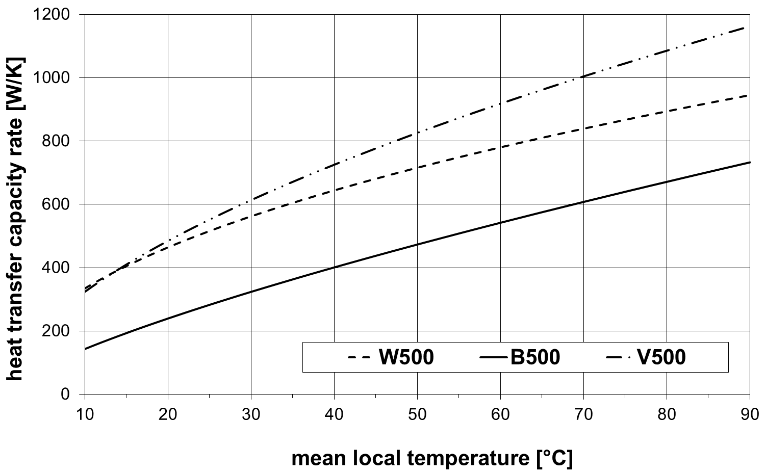

Figure 8: Heat capacity rate of the auxiliary heat exchangers (volume flow rate 2153 /h)

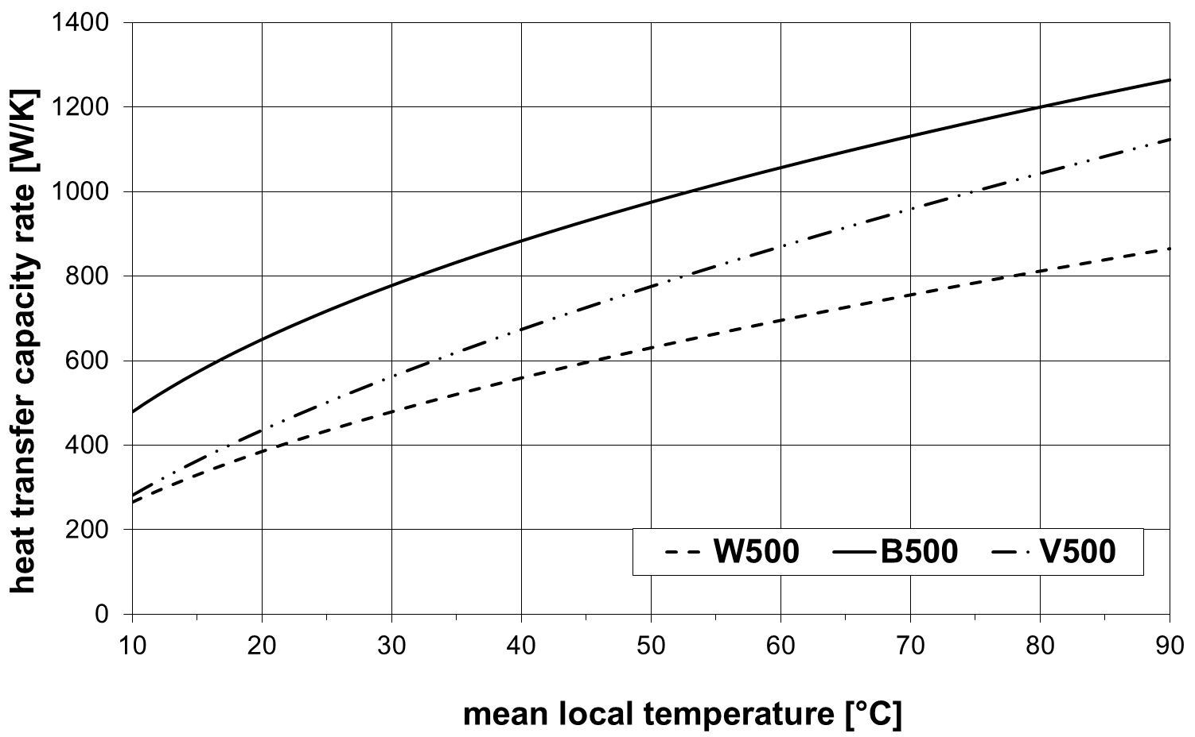

Figure 9: Heat capacity rate of the solar loop heat exchangers (volume flow rate 300 /h)

|  |  |  |  |
| --- | --- | --- | --- |
|  | W500 | B500 | V500 |
| Heat losses of store [kWh/a] | 707 | 797 | 741 |
| Heat losses of collector loop [kWh/a] | 336 | 348 | 337 |
| Collector energy gain at HX [kWh/a] | 3207 | 3254 | 3167 |
| Auxiliary heat demand [kWh/a] | 1926 | 1962 | 2001 |
| **fsav [%]** | **61,9** | **61,2** | **60,5** |

Table 5: Results of the annual system simulations

1. **Summary**

A method was developed to assess the thermal performance of DHW stores and to compare DHW stores with the same nominal volume by determining the fractional energy savings fsav under reference conditions. In order to avoid too many classes of stores it is useful to round the nominal volume to the next complete 10 litres if not already done by the manufacturer. For comparison it is important, that the stores with the same nominal volume provide the same “hot water volume” Cu (according to EN 15332:2007). Due to the fact that the auxiliary volume (and the correspondent temperature sensor in most cases) of the stores are fixed, the “hot water volume” Cu has to be set by varying the set temperature for the auxiliary heater. This set temperature has to be used for the annual system simulation to determine the fractional energy savings fsav according to EN 12977-2:2012. Since the stores provide the same “hot water volume” Cu (stores with the same nominal volume) the fractional energy savings fsav can be used as an annual store indicator. It is suggested to call this parameter e. g. fsav,sto300 to indicate that it is about fractional energy savings determined for a store with a nominal volume of 300 litres under reference conditions.

The application of this method to 3 DHW stores with a nominal volume of 300 litres and 3 DHW stores with a nominal volume of 500 litres has shown reasonable results.

As an alternative method it is in principle possible to use fsav and Cu as two independent parameters to specify the store indicator. In this case the hot water volume Cu and the fractional energy savings fsav can be determined with the same set temperature for all stores. So in general the stores differ in both values even if they have the same nominal volume. The advantage of this method is the additional information about the hot water performance of the store, because the “hot water volume” Cu is given for a uniform auxiliary set temperature. The disadvantage of this method is that it is much more difficult to compare the stores regarding their whole thermal performance. If one store has a higher value regarding fsav and another one has a higher value regarding Cu it is not possible to compare their thermal performance. Therefor it is suggested to use fsav,sto as one parameter which describes the whole thermal performance of the store.

Appendix A:

**A1 Influence of the location**

In Chapter 5 the method was applied using the TRY Würzburg. Generally other locations such as Davos, Stockholm or Athens according to EN 12977-2:2012 could be used for the annual system simulation. To investigate the influence of the location, the annual system simulations were additionally performed using the above mentioned locations. Table A1 shows the results (for a better comparison again with the results from Würzburg).

|  |  |  |  |
| --- | --- | --- | --- |
| fsav [%] | W300 | B300 | S300 |
| Würzburg | 62,0 | 59,1 | 56,8 |
| Davos | 80,7 | 76,4 | 74,9 |
| Stockholm | 58,9 | 54,9 | 53,4 |
| Athens | 89,1 | 86,1 | 84,3 |

Table A1: Fractional energy savings for different locations according to EN 12977-2:2012

Table A1 shows that the location has no influence on the ranking of the stores. That means that the stores can be compared using any of the locations. Anyway it is recommended to use TRY Würzburg, because it represents a medium climate in Europe.

**A2 Influence of the store volume**

A2.1 Store W300 with smaller volume

The store W300 has a total usable volume of 336,3 l. As a store with a nominal volume of 300 l the usable volume could be 270 l too. To investigate the influence of the volume on the annual store indicator it is assumed, that the usable volume of the store should be 270 l. The heat loss rate is adapted to 2,32 W/K using the method according to EN 12977-3:2012, Annex E. All other parameters of the store are not changed. Table A2 shows the parameters of this fictive store.

|  |  |
| --- | --- |
| **Parameters\ Store** | **W300** |
| Nominal volume [l] | 300 |
| required hot water volume Cu [l] | 150 |
| Determined hot water volume Cu [l] | 148,9 |
| Total usable volume of the store [l] | **270** |
| Heat loss rate [W/K] | 2,32 |
| Effective thermal conductivity [W/Km] | 1,81 |
| Rel. height inlet cold water [%] | 0 |
| Rel. height outlet hot water [%] | 100 |
| Number of nodes for the store [-] | 108 |

|  |  |
| --- | --- |
| **Collector loop:** | |
| Solar volume inclusive solar-HX [l] | 159,3 |
| Rel. height connection of collector flow [%] | 43 |
| Rel. height connection of collector return [%] | 0 |
| Rel. height of store temp. sensor [%] | 9 |
| Max. mass flow rate [kg/h] | 200 |
| Pipe inside diameter [mm] | 13 |
| Device for thermal stratification | no |
| Maximum store temperature [°C] | 90 |
| Switch on/off temperature | 10/3 |
| Matched flow/ set temperature difference between collector and store [K] | Yes/ 10 |
| **Auxiliary heating:** | |
| Auxiliary volume exclusive HX volume [l] | **104,7** |
| Auxiliary set (switch on) temperature [°C] | **54,5** |
| Hysteresis [K] | 5 |
| direction of flow | down - top |
| Relative position of aux. temp. sensor [%] | 70 |
| Relative position of aux. inlet [%] | 85 |
| Relative position of aux. outlet [%] | 59 |
| Power of auxiliary heater [kW] | 15 |
| Mass flow rate [kg/h] | 1292,0 |
| Max. flow temperature [°C] | 70 |
| **fsav [%]** | **57,7** |

Table A2: Store parameters and result for fictive store W300

Table A2 shows that the auxiliary set temperature has to be increased considerably from 46 °C to 54,5 °C to get the same hot water volume Cu, because the auxiliary volume of the store is much smaller than for the real store. This is the main reason, why the fractional energy savings fsav drop from 62 % to 57,7 %. Hence the store volume has a great influence on the fractional energy savings respectively on the store indicator. But this doesn’t contradict the proposed method, because the store volume is an important parameter for this application.

A2.2 Store W300 indicated with a nominal volume of 350 l

As already mentioned, the store W300 has a total usable volume of 336,3 l. Therefore the nominal volume could be 350 l too. To investigate the influence of the nominal volume on the store indicator the store is treated with a nominal volume of 350 l. Table A3 shows the parameters and the result of the annual system simulation for this case.

|  |  |
| --- | --- |
| **Parameters\ Store** | **W300** |
| Nominal volume [l] | **350** |
| required hot water volume Cu [l] | **175** |
| Determined hot water volume Cu [l] | **175,0** |
| Total usable volume of the store [l] | 336,3 |
| Heat loss rate [W/K] | 2,59 |
| Effective thermal conductivity [W/Km] | 1,81 |
| Rel. height inlet cold water [%] | 0 |
| Rel. height outlet hot water [%] | 100 |
| Number of nodes for the store [-] | 108 |
| **Collector loop:** | |
| Solar volume inclusive solar-HX [l] | 159,3 |
| Rel. height connection of collector flow [%] | 43 |
| Rel. height connection of collector return [%] | 0 |
| Rel. height of store temp. sensor [%] | 9 |
| Max. mass flow rate [kg/h] | **233** |
| Pipe inside diameter [mm] | 13 |
| Device for thermal stratification | no |
| Maximum store temperature [°C] | 90 |
| Switch on/off temperature | 10/3 |
| Matched flow/ set temperature difference between collector and store [K] | Yes/ 10 |
| **Auxiliary heating:** | |
| Auxiliary volume exclusive HX volume [l] | 104,7 |
| Auxiliary set (switch on) temperature [°C] | **51,5** |
| Hysteresis [K] | 5 |
| direction of flow | down - top |
| Relative position of aux. temp. sensor [%] | 70 |
| Relative position of aux. inlet [%] | 85 |
| Relative position of aux. outlet [%] | 59 |
| Power of auxiliary heater [kW] | **17,5** |
| Mass flow rate [kg/h] | **1507** |
| Max. flow temperature [°C] | 70 |
| **fsav [%]** | **57,5** |

Table A3: Parameters and result of the annual system simulation for store W300 treated with a nominal volume of 350 l

The bold printed letters show the changed parameters compared to table 1. As a store with a nominal volume of 350 l the required hot water volume Cu has to be 175 l. Therefore the auxiliary set temperature has to be raised from 46 °C to 51,5 °C because the auxiliary volume of course didn’t change (same store). The mass flow rate in the collector loop has changed because the collector area has been raised from 5 m2 to 5,83 m2. Furthermore the power and the mass flow rate of the auxiliary heater was adapted according to chapter 3. The daily hot water load was adapted to 250 l according to chapter 4. The fractional energy savings drop from 62 % (nominal volume 300 l) to 57,5 % (nominal volume 350 l). It has to be mentioned that the two results can’t be compared because of the different nominal volumes (different classes of stores).

1. Both connections of the solar loop heat exchanger are at the bottom. The best performance of the store model is achieved if the connection of the return flow is above the connection of the flow.
2. Both connections of the solar loop heat exchanger are at the bottom. The best performance of the store model is achieved if the connection of the return flow is above the connection of the flow.