23rd Solar Keymark Network meeting

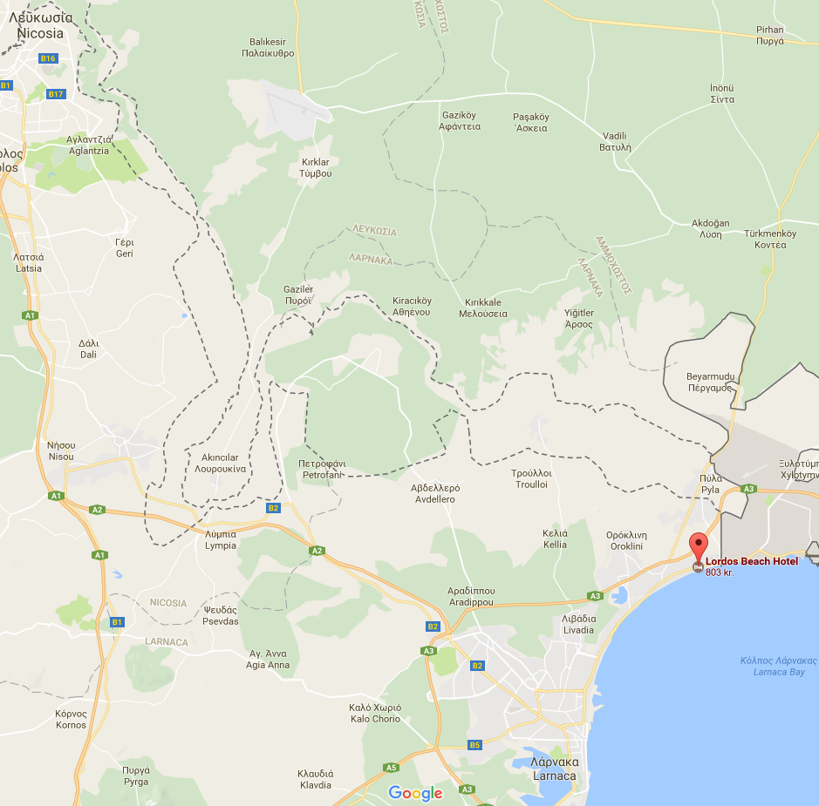
Initial draft agenda (R1)
2017-07-03, JEN/JF

Meeting time:
Tuesday, October 17th, 2017, 13:00 - 19:00
Wednesday, October 18th, 2017, 09:00 - 14:00
Meeting location:
Lordos Beach Hotel
Dhekelia Rd, Larnaca 7081, Cyprus
Phone: +357 24 647444

Web conference login - to come

Related meetings same place:
- CEN TC312 xx/xx

Registration deadline 7th September
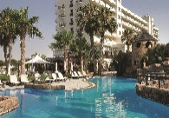
Registration is done using form in
separate spreadsheet file SKN_N0332R0.
Please fill in and send this form to:
Irene Manti: imanti@tuv-nord.com
Jan Erik Nielsen: jen@solarkey.dk

Hotel booking should be done before end of May – see end of
this document

The meeting is Hosted by TÜV NORD CYPRUS
Tuesday, 13:00
Item | Decision/-resolution  requested | Related to decision  of last meeting | Time (min) | Topic/content/responsible |  | Related documents /comments/details
0 |  |  | 60 | Arriving & lunch (13:00 – 14:00) – welcome by host
1 |  |  | 5 | Opening of the meeting /JF  Short welcome from chairman - and some practical information
2 |  |  | 10 | Introduction of participants /All  Excuses from:  - …  Attending via web:  - …
3 | x |  | 5 | Approval of the agenda /All
4 | x |  | 5 | Comments to the minutes of the SKN meeting 21A (web) /JF, All  - |  | SKN_N0330R0_ Minutes22_SKNmeeting_Draft.pdf
5 | (x) |  | 5 | Review of Decision list and follow up of action list /JF/JEN  Action list |  | N0100R20_DecisionList pdf  SKN_N0286.R9_ActionListFor23SKNmeeting2017-05-16.xlsx
6 | x |  | 20 | Structure/organisation of SKN meetings /JF,PD,JEN  Starting in 2018, the structure of SKN meetings changes into one physical meeting to be held in spring time and one WEB meeting to be held in autumn. There will be a proposal for the structure of the meetings to be presented in the autumn meeting of 2017. During the physical meeting to be held in autumn 2017, a web tool for online meetings (and voting) will be used as a final practice.  Resolution … |  | Document/presentation? / JF, JEN?  Equipment? / PD?
7 | x |  | 20 | Date and place of next meeting(s) /JF, JEN  - 24nd SKN meeting: March 6th 13:00 to March 7th 14:00, 2018 - Madrid, AENOR,  - 25th SKN meeting: October 2018. Web meeting  Note: The item “Next meeting” is put first in the agenda, as it is kind of decision item.
8 | x |  | 20 | Voting procedures for web meetings / K Meyer  Proposal for resolution on voting procedures for web meetings. K. Meyer - "Participation Rules WG"  Resolution … |  | Document/presentation? /k Meyer
9 | (x) |  | 20 | Report and Decision/Resolution? from "10% Rule WG" / H. Drück  … |  | Document/presentation? / H Drück
10 | x |  | 20 | Updates and proposal for Resolution/Decision? on systems data sheet / M. Carvalho  Decision …  Resolution … |  | Document/presentation? / U. Fritzsche
11 | x |  |  | Transition process for new version of EN 12976-1+2/ (Part 1 K. Meyer?) (Part 2 U.Fritzche?)  - Presentation of changes in Product standard EN 12976-1. Any proposals for Resolution in Scheme Rules?  - Presentation of changes in Testing standard EN 12976-2. Any proposals for Resolution in Scheme Rules?  - Resolution for adapted data sheet to EN 12976-2  - Transition process. Proposal for Decisions: All new Certificates issued in compliance with EN 12976-1 :2017 and new adapted version of data sheet to EN 12976-2:2017. All new revisions according to EN 12976:2017 data sheet. Any gap testing necessary? |  | Documents/presentations ?
12 | (x) |  | 40 | Transition process for new EN/ISO 9806 /JF, A Bohren  Discuss/decide:  a) How long will it take for laboratories to update their accreditation to the new standard?  b) How long will it take to prepare a new version of the data sheet?  c) Should there be a transition period in which certificates are granted different with versions of the standard? (because not all labs will update their accreditation simultaneously?)  d) Are any CBs making reference to the ISO 9806 in their accreditation and certificates, if so, how long to update?  e) The Com&Mkt WG should inform about the change in standard and transition process  Decision … |  | Document/presentation? / JF, A Bohren?
13 | (x) |  | 15 | Updates on collector data sheet? - need for allocation of funding? / P. Ollas  Decision … |  | Document/presentation? / P. Ollas?
14 | (x) |  | 15 | Report and Decision/Resolution from Air "Collectors WG" / k. Kramer  Decision …  Resolution … |  | Document/presentation? / K. Kramer
15 | x |  | 20 | Report and Decision/Resolution proposals from PVT WG - presentation of "show cases" / U. Fritzsche  Decision …  Resolution … |  | Document/presentation? / U. Fritzsche
16 | (x) |  | 5 | New Equivalent absorber coatings? |  | Document/presentation? / ?
17 | (x) |  | 5 | New Equivalent glazing? |  | Document/presentation? / ?
18 | (x) |  | 5 | New Equivalent insulation? |  | Document/presentation? / ?
19 | (x) |  | 15 | Update (decisions?) regarding new EN 12975? /A Bohren  Is there need for an SCF Project to pay an expert in CPR standards?  Transition period for EN 12975? |  | Document/presentation? / JF, A. Bohren
20 | x |  |  | Proposal for decision on ‘thermodynamic’ solar collectors/J R Hernández, AENOR  The AENOR Certification Committee has found a problem with certifying ‘thermodynamic’ collectors. A proposal for decision that explains why they fall under scope of standard is needed. |  | Document to come from AENOR Committee
21 | x |  | 15 | SKN fees and budget for 2018 and other financial issues / JEN &PD  Proposal for decision on budgets: Approve attached budgets  Proposal for decision on fees:: Keep the fees unchanged |  | Budget proposals / JEN, PD
22 |  |  | 10 | Update on voting of new SCF Chairman /JF
23 | x |  | 25 | Proposal for decision: Priorities for SCF 8th call / JEN  Proposals for priorities:  - … / ?  - … / ?
24 |  |  | 20 | Report by CB WG on web inspection - report from pilot project? / A. Bohren & U. Fritzche  … |  | Document/presentation? / A. Bohren, U Fritzdche
25 |  |  | 15 | Report or Update on “Inter-laboratory Comparison - ILC on Data Analysis”, SCF7 Project / A. Bohren  … |  | Document/presentation? / A. Bohren
26 |  |  | 15 | Information from CEN Keymark Management / K Meyer  … |  | Document/presentation? / ?
27 |  |  | 30 | Update on complaints / JF  Report from complaint committee |  | Document/presentation? / ?
28 |  |  | 20 | Update on Action Plan working groups:  Strategy WG (JF)  AP2 Marketing and Communication WG (PD)  AP3 Installers WG (KM)  AP6 Legal Requirements (GVA) |  | Document/presentation? / ?
29 |  |  | 15 | Solar Certification Fund Projects – General Status Reports / PD  … |  | Document/presentation? / PD?
30 |  |  | 10 | Update on Global Solar Certification Network / JEN  … |  | Document/presentation? / JEN?
31 |  |  | 15 | Update on detailed SK database / JEN  … |  | Document/presentation? / JEN?
32 |  |  | 20 | Important updates / other important information:  - Updates from Liaison officers:  - S.Fischer (IEC/TC117)  - K.Kramer(IEC/TC128)  - J-M. Suter (TC164)  - G.v.Amerongen(TC 228 and TC371)  - Energy labelling /GvA  - Standing WGs / CB S.Scholz and IB JF  - V. Drosou (TC 312)  - Labelapck A+ project /PD  - Clean Energy Package / PD  Any misuse of Solar Keymark ? |  | Document/presentation? / ?
33 |  |  | 15 | Any other business |  | Document/presentation? / ?
34 |  |  | 5 | End of meeting /JF
 |  |  |  |  | Meeting ends 14:00
Meeting duration
JF: Jaime Fernandez, AENOR, Chairman Solar Keymark Network, JAFERNANDEZ@aenor.es
JEN: Jan Erik Nielsen, Solarkey Int., ESTIF Technical Consultant, Manager of Solar Keymark Network, jen@solarkey.dk
PD: Pedro Dias, ESTIF Secretary General, Administrative Secretary of Solar Keymark Network, pedro.dias@estif.org
Potential subjects for next meeting:

Meeting plan | Cyprus |  | October | 2017
 | Tuesday 17th October |  |  | Wednesday 18th October |  |  |  | Thursday 19th March |  |  | Estimated no. people
 |  | Lunch  13-14 | 14 - 19 | 9 - 14 |  |  |  | 9 - 18 |  |  |  |  |  | Location
Solar Keymark Network |  | x | x | x |  |  |  |  |  |  | 40 |  |  | Lordos Beach Hotel
CEN/TC312 |  |  |  |  |  |  |  | x |  |  |  |  |  | Lordos Beach Hotel

WEB meeting login: (to come)

…

Recommended hotels:

Lordos Beach Hotel
Book before end of May to have special price:
Standard side sea view room, single occupancy : €80.00 per night
Standard side sea view, double room : €110.00 per night
Superior side sea view room, single occupancy : €90.00 per night
Superior side sea view, double room : €130.00 per night

