SKN Online Meeting & Voting Tool
Join the online meeting:
A computer will be necessary to start the online meeting tool.
Clicking on the link corresponding to the date will launch the online meeting tool and allow you to join the SKN online meeting:
- For October 17: https://global.gotomeeting.com/join/484755957
- For October 18: https://global.gotomeeting.com/join/475363829
In order to launch the software, it will be necessary to accept the request sent by your browser and click on “Open GoTo Opener” (see picture below).
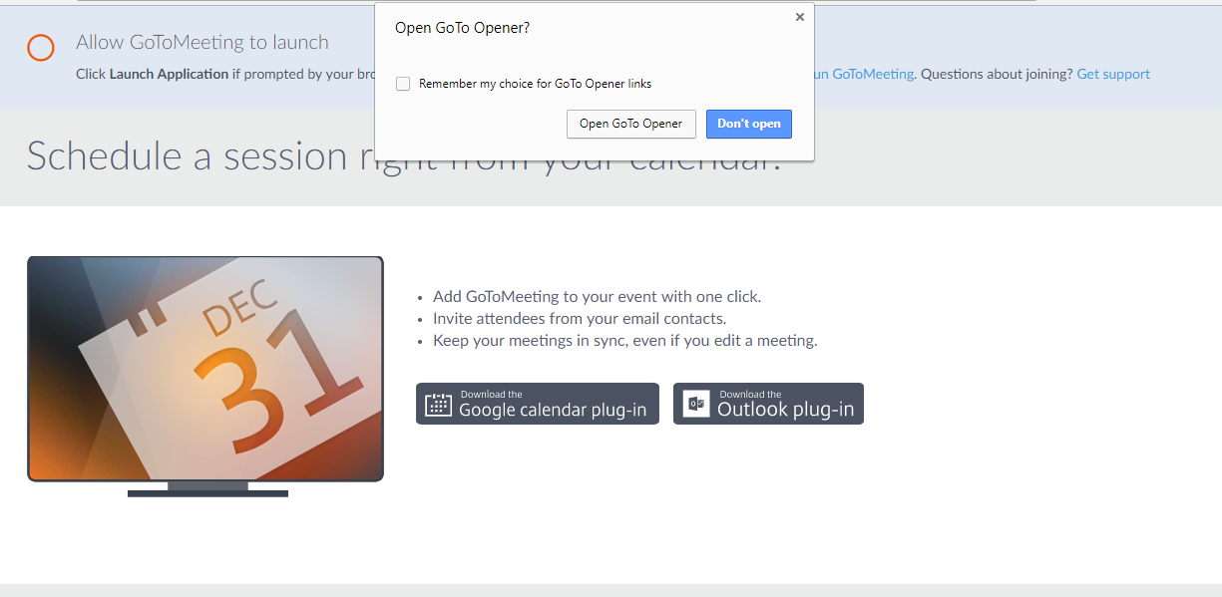

Two options exist to set the audio of the online meeting tool, you can either use your computer audio or join the meeting via phone.
Phone sound option:
In case you need to join the meeting via phone, choose the country where you are and dial the number in the dial section, then indicate the access code and the PIN (see picture below).
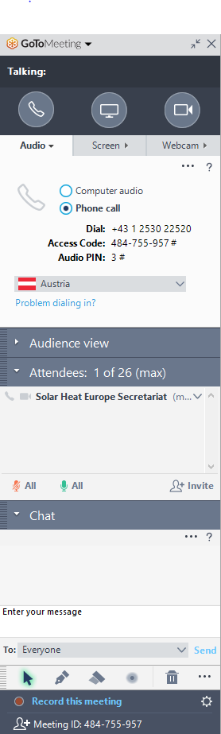

Voting Process:
You can use the online voting tool with any smart devices which can be connected to the internet (tablets, computers, and smartphones). An internet connection will also be necessary.
PLEASE NOTE: only those with voting rights can vote. Other participants are allowed to see the evolution of the vote. In this case they should access as “OTHER” (see below). Participants from one of the SKN members that are not the main representative (additional participants), should access as “OTHER”.
For joining the online to vote, connect the following website: https://www.sli.do/
The SKN organisers will disclose an Event Code number during the meeting. For explanation purposes, we will use a fictive event code in this document: #1234
Writing in the dedicated box in the home page website will lead you to the SKN voting tool section (cf: picture below.)
Before reaching this section, it will be necessary to provide:
- Type of entity (initials – see below)
- Entity acronym
- First name and last name.
Prior to your full name, it will be needed to add the SKN category initials of your sector as indicated below:
- Test Labs = TL
- Industry = IN
- Certification Body = CB
- Other = OT (*)

(*) Other applies to guests or other persons without a voting right, such as additional representatives of an organisation. Please separate with a hyphen.

So, if you are representing a test lab named Tester and you are called Jack Expertise, it will be necessary to display your name as follows: TL – Tester – Jack Expertise (See below).
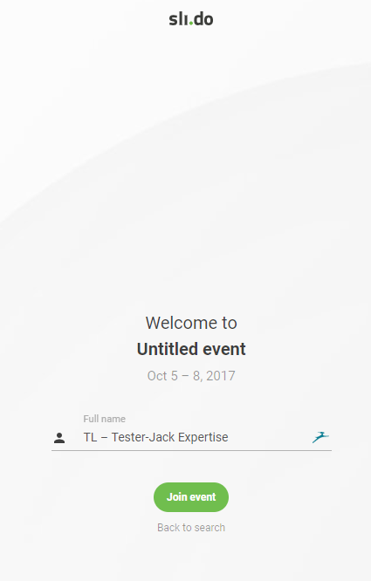I

To access the poll and vote, click on the polls tab. Then, it will be possible to choose on an answer and send it to the organisers.
PLEASE NOTE: Only one person per organisation can vote. Other representatives can watch the vote, as long as they login as “Other’” (see before).

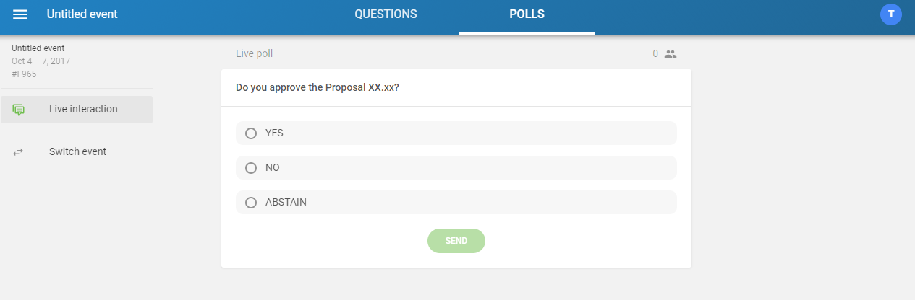

The first poll which will appear on your screen is a question which will allow the SKN organisers to identify if the quorum of the meeting has been reached.
Please fill in the poll only if you have voting rights.
