Marketing Plan for the Solar Keymark

Geoffroy Cazenave
Pedro Dias
Jaime Fernández
Katharina Meyer
Marisol Oropeza
Henry Rosik

Index
1. Background
2. Definitions
3. Stakeholder Analysis
4. Communication and Marketing goals
5. Marketing Mix by stakeholder group
6. Summary of ongoing and future tasks

- BACKGROUND
Following the decision of the SKN to address, under the action plan, to launch a “Marketing and Communication WG”, one of the goals defined was to assess the needs of SKN in terms of promotion and marketing. This work, carried out by the SKN Communication Working Group over 2016, resulted in a proposal to develop a marketing plan for SKN (as well as some resources), which was included in a SCF project (8C07.1). The SKN Communication Working Group has worked since March 2017 on the development of the current Marketing Plan.
With the support of an external consultant in communications and marketing, the working group has been able to acquire the necessary knowledge to develop such a plan and started to structure their work accordingly via the use online tools.
Based on the work produced by the SKN Strategy Working Group, the Communication Working Group has been able to identify and profile in detail the potential target groups which could interest SKN to promote the Solar Keymark.
This process included a review by peers of the different identified targets as well as an equal repartition of the work between the different Working Group members to identify potential target’s needs.
The support of the external consultant, Marisol Oropeza from Matters Consulting, has been determinant to process the information and drive the work of the Communications Working Group towards a structured and understandable manner of approaching on a good basis this document.
The current document has been finalised by the following members of the SKN Communications Working Group: Jaime Fernandez, Jan Erik Nielsen, Pedro Dias, Henry Rosik and Britt Bremer.
The following marketing plan is a first draft and will be updated based on the comments provided by the SKN members during the SKN annual assembly.
As a result of the Strategy and Communications Working groups, this Marketing Plan aims at giving the basis of a SKN structured communications which promotes its services approach, including the current “services” as well as those which are in current development and those which could be developed in a close future.

- DEFINITIONS
The approach that was followed to develop this marketing plan was to consider the Solar Keymark Network(SKN) as if it was a company with the following characteristics:

- The SKN offers the main service of the Solar Keymark, a European Quality Mark for OEM manufacturers and OBL companies. The certification activities are managed by the SK Operators (CB, TL and IB);

- The SKN also offers secondary services:

  - A self-operating scheme for SKN Operators.
This means continuously updating the scheme rules, making complex technical decisions and helping out with commercial activities. This service is provided through the Secretariat which is held by Solar Heat Europe (ESTIF) and with help of volunteering of SKN members.
    - It allows CBs to save time and money by not having to run these activities through their own Certification Committees. CBs add will then the Keymark to their portfolio of Quality Marks and offer it as service;
    - Testing labs saves time and money by referring to a list of technical decisions to apply when testing products.
- Funding and managing Solar Certification Fund Projects

- STAKEHOLDER ANALYSIS
Simultaneously to the development of this marketing plan, another project was working on a formal strategy for the Solar Keymark (SCF-8 Strategy). This strategy working group elaborated an analysis of the stakeholders which have an influence on the Solar Keymark Network. The outcome of this analysis was used as input for the marketing plan and it has become the backbone of both the marketing plan and the future strategy.

After applying the approach that was mentioned in chapter 2, the following diagram was developed. It is based on the flow of money and it shows a summary of the definitions and interactions between stakeholders:

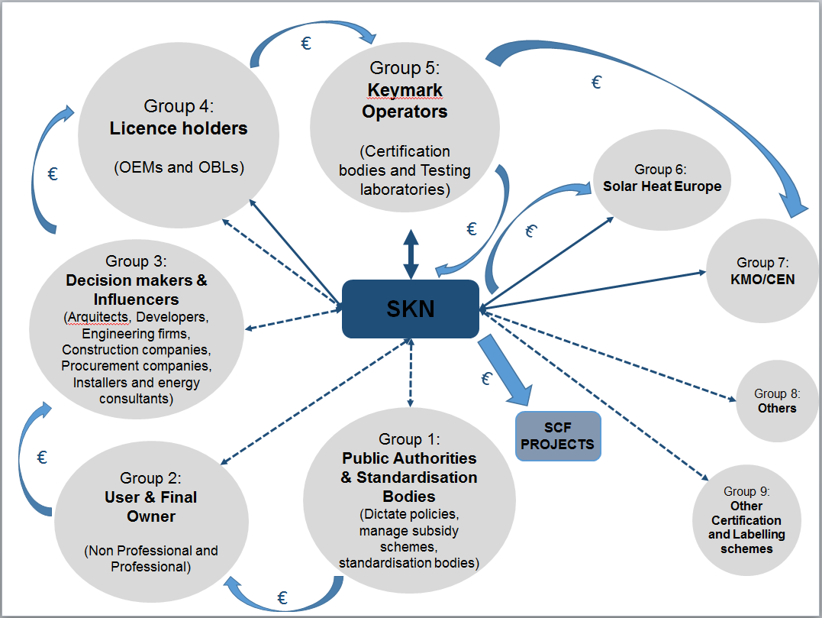

Besides carefully describing each Stakeholder Group and its subgroups, the following questions were answered for each one:

1) Does it pose a threat or offer a benefit to the SK? Is it expected to change in the future?
2) What benefit does it obtain from the SK?
3) Description of its relationship with the SK. Who is its contact within the SKN?
4) What is the ideal state of this stakeholder? How important is it for the SK?

This work can be read in full detail in the document ‘Stakeholders of the SKN’. This document could be communicated upon request.

Following a similar methodology of work, the marketing group then analysed each stakeholder group(and subgroup) individually.

Each analysis began with two main questions:

1) Communication Goals- What do we want the stakeholder to think?
2) Marketing Goals- What do we want the stakeholder to do?

The next set of questions were directly related to the four Ps in marketing: What is the Product we are selling? In which Place are we selling it or what is its placement? What is the Price? What Promotion activities are we doing? And we had to add another one: what is the Service we are providing?

By answering these questions and afterwards arranging the answers the group was able to provide a complete marketing plan.

Many actions are already underway as part of the Project SCF8- Promotion_ESTIF. Thanks to this complete marketing plan these actions may be developed with a clearer understanding as to what is the message, to whom we wish to deliver it to and under what means of communication system.

Some new actions have been proposed and the group has concluded that some existing actions will require some extra funding to be kept up in the future. There is also an interesting new service related to the SKN as an entity that is proposed to be further examined.

- COMMUNICATION AND MARKETING GOALS
One of the most innovative actions that the group has come up with is preparing a set of communication and marketing goals. Many of these will apply to more than one stakeholder at a time, and in a different level of importance for each stakeholder.
Communication goals alter a thought process of the target group. They create awareness and transmit core messages. They have an impact on the positioning of a product or service. The main question is: what do we want a specific stakeholder group to think?
Marketing goals change the behaviour of the target group. The main question is: what do we want this stakeholder group to do?
The tactical actions proposed in the marketing mix presented in chapter 5 should contribute to reaching both communication and marketing goals.
4.1 COMMUNICATION GOALS
Communication goals may be common to all stakeholder groups or only to some of them. Especially the definition of the SK and SKN is a core message that needs to be transmitted to all stakeholder groups.
Communication goals common to all stakeholder groups:
SK is quality mark/certification scheme for solar thermal products widely used in Europe and in operation for over 10 years. It has an international profile also outside Europe.
The SK is managed by the SKN, a European group of experts representing relevant stakeholders from the European solar thermal sector.
Communication goals by type of contribution:
All other communication goals have been clustered in different categories according to their main contribution to core message for several stakeholder groups.
- Contribution to knowledge and expertise
- The SKN is a technical partner that provides assistance for a better understanding of the certified data, and provides advice on communicating the benefits of the SK.
- The SKN members that work in standardisation committees bring an important experience as European experts in solar thermal products.
- The SKN provides fast access to new knowledge and information on news or changes in SK scheme rules.
- The SKN members exchange information and knowledge actively and periodically in order to update and streamline the scheme rules, as well as to find solutions to complex technical matters.
- The SKN allows for a balanced approach between industry, certification and test labs regarding the framework and working rules of the SK.

Mostly relevant for the following target groups:
  - Public authorities that dictate policies and manage subsidies
  - Standardisation bodies
  - Decision makers and influencers
  - Licence holders: manufacturers and OBL companies
  - Keymark operators: certification bodies and testing laboratories

- Contribution to standards and certification
- The SK adds value to established standards. It makes standards more valuable to many stakeholders and may help to promote their use.
- The SK enhances business for testing, inspection and certification.
- The SKN saves time and reduces costs for certification bodies and test labs with respect to a self-operated certification scheme.

Mostly relevant for the following target groups:
  - Public authorities that dictate policies and manage subsidies
  - Standardisation bodies
  - Licence holders: manufacturers and OBL companies
  - Keymark operators: certification bodies and testing laboratories

- Contribution to quality assurance
- The SK assures that solar thermal products sold are reliable and are meeting quality standards.
- The SK assures compliance with standards and provides certified technical data.
- The SK improves internal processes and quality assurance, as well as technical competence in the solar thermal manufacturing industry.

Mostly relevant for the following target groups:
  - Public authorities that dictate policies and manage subsidies
  - Standardisation bodies
  - Licence holders: manufacturers and OBL companies
  - Keymark operators: certification bodies and testing laboratories
  - ESTIF
  - Decision makers and influencers

- Contribution to marketing
- The SK certificates contain verified technical data of solar thermal products.
- The SK provides an assurance of the quality of the solar thermal products.
- The SK helps to understand the performance of solar thermal products.
- The SK can be used to better position the product being recommended/sold, and is worth presenting/communicating.
- The SK increases notoriety of solar thermal products.

Mostly relevant for the following target groups:
  - Public authorities that dictate policies and manage subsidies
  - Standardisation bodies
  - Licence holders: manufacturers and OBL companies
  - Keymark operators: certification bodies and testing laboratories
  - ESTIF
  - Decision makers and influencers
  - Non-industry

- Contribution to sales and exports
- The SK is a European mark that facilitates sales and exports by reducing barriers to trade at European and international level.
- The SK facilitates the introduction of new products into the market by reducing the cost of innovation, time to market, and administrative burden.
- The SK facilitates access to subsidy schemes in many countries.

Mostly relevant for the following target groups:
  - Public authorities that dictate policies and manage subsidies
  - Standardisation bodies
  - Decision makers and influencers
  - Licence holders: manufacturers and OBL companies
  - Keymark operators: certification bodies and testing laboratories
  - ESTIF

- Contribution to policy making and subsidy schemes
- The SK can be used as a tool that supports the design and implementation of national policies.
- The SK provides reliable technical information about solar thermal products for subsidy schemes.

Mostly relevant for the following target groups:
  - Public authorities that dictate policies and manage subsidies
  - Standardisation bodies
  - Decision makers and influencers
  - Licence holders: manufacturers and OBL companies
  - Keymark operators: certification bodies and testing laboratories
  - ESTIF

4.2 MARKETING GOALS
Since marketing goals are meant to trigger action of a specific target group, they have been defined and grouped by stakeholder group.
Public policy / Subsidy schemes
- Recognise the SKN as an entity that could be involved in consultation processes
- Contact SKN representative when drafting new policies or making amendments to current policies related to heat and solar energy (personal contact)
- Get information about solar thermal technologies and certified products through the database of the SKN, as well as of subsidy schemes in other EU countries
- Use SK in subsidy schemes
- Recognise the SKN as an entity that could be involved in consultation processes

Standardisation bodies
- Prioritise standards used by the SK to receive most resources for the best development and follow up
- Consider SKN as a partner to help develop standards and to promote them also

Non-Industry
- Tell other end users about the benefits
- Approaches SKN to understand the SK

Decisions makers & Influencers
- Require or at least prefer products with SK certificates in regulation, subsidy schemes and labelling schemes
- Inform other market players about the processes and reliability
- Contact SKN representative when drafting new policies or making amendments to current policies related to heat and solar energy (personal contact

Licence holders/ Manufacturers
- Use the SK as a valuable asset in their communication strategy and materials, and sales processes:
  - The SK is explained /highlighted in online communication such as website
  - The SK is included in technical workshops (installers)
  - Show the SK in trade fairs and promotional events
- Contact SKN for any technical question related to the SK, its recognition in other countries and/ or lobby activities for technical aspects

Licence holders / OBL companies
- Ask or sell only SK certified collectors
- Use the SK as a valuable asset in their communication strategy and materials, and sales processes:
  - The SK is explained /highlighted in online communication such as website
  - The SK is included in technical workshops (installers)
  - Show the SK in trade fairs and promotional events

KEYMARK Operators/Certification bodies
- Each CB actively promotes the SK as one of its important Quality Marks and actively searches new clients based on promotional activities and promotional kit
KEYMARK Operators/Testing labs
- Participate in SKN meetings and SKN WGs
- Use newsletter after each SKN meeting to check important news e.g. in SK scheme rules

Solar Heat Europe (ESTIF)
- Support the work of SKN, both internally and externally
- Engage industry and Solar Heat Europe (ESTIF) members on SKN and product certification
- Promote synergies between policy proposals, technical requirements and market needs
- Exploit the potential of SKN for providing reliable data to consumers and authorities

- MARKETING MIX BY STAKEHOLDER GROUP
The marketing mix is presented in attached table
- SUMMARY OF ONGOING AND FUTURE TASKS
The whole process to create this marketing plan has been useful to identify needs of stakeholders and then create and adapt current SKN product/services.
Please find a list below of the tasks (ongoing and to be developed) that are related to the marketing plan implementation.
Table of the tasks ongoing
Task | Related activity
Develop a promotional kit for CBs by adapting the future promotional kit for License holders. | SCF 8C07.1 - Promotion_ESTIF
Video for ‘dummies’, technical brochures or videos. | SCF 8C07.1 - Promotion_ESTIF
Develop a presentation for “dummies” | SCF 8C07.1 - Promotion_ESTIF
Develop a more detailed information package about the technical tests (including short movies of tests from different tests centers) to technicians and thoroughly explain the datasheet | SCF 8C07.1 - Promotion_ESTIF
Develop a SK promotional kit (FAQs, video, brochure, presentation, charts, infographics) for licence holders, so they can include this information easily in their marketing and sales materials (web, trade fairs and technical workshops). | SCF 8C07.1 - Promotion_ESTIF
Database of certified products - special service for public entities | SCF 5C6.1 - DATABASE_SKI / 7C04 - Label-DB
Gather information on subsidies schemes from different countries and distribute the information | SCF 8C07.1 - Promotion_ESTIF
Improve the “database of certified products” and adapt it to the needs of this stakeholder group | SCF 5C6.1 - DATABASE_SKI / 7C04 - Label-DB

Table of the tasks foreseen depending on future calls
Task | Project to be created
Content Plan | To be defined
Improve the “database of certified products” and adapt it to the needs of industry and market, namely the complementarity with Energy Labelling or other obligations. | To be defined
Develop a more detailed information package about the technical tests (including short movies of tests from different tests centers) to technicians and thoroughly explain the data sheet. | To be defined
Quality of the products consistent and reliable | To be defined
Highlight the benefit that the SK has on the definition and use of parameters of a subsidy scheme | To be defined
Study the feasibility of the services provided by the SKN as an institution and to communicate this also: update of subsidy maps, consultation services especially related to international recognition of Solar Keymark, consultation services with technical issues regarding Solar Keymark and other technical needs of license holders. | To be defined
Maintenance of the European Map of Subsidies | To be defined
Newsletter management | To be defined
Set up a “(sales) task force” that defines a local strategy to promote the SK for subsidy schemes | To be defined
Ensure that services and services access for Public Authorities, Architects/Developers/engineering firms and construction companies, procurement companies, installers group are clearly described in all communication channels such as website, presentation, brochure/flyer, newsletter. | To be defined

In the communication is important to refer to the Solar Keymark as a “quality mark” when addressing non-technical stakeholder groups, whereas the term “certification scheme” should be used when addressing target groups with a more technical background or those target groups for whom is relevant to know the process behind the quality mark.
Including collectors, controllers, storage tanks, and factory-made systems

