Section A: Solar Keymark WP1.A input to CEN/TC 312 WG1

Section B: Solar Keymark WP1.B input to CEN/TC 312 WG2

Section C: Solar Keymark WP1.B input to CEN/TC 312 WG3



Internal procedures for Solar Keymark WP1.A
and input to CEN/TC 312

Version: 1

Edited by:
Åsa Wahlström
SP Swedish National Testing and Research Institute

Solar Keymark
WP1.A
Network for implementing standards
Solar Collectors

Internal procedures for Solar Keymark WP1.A

and input to CEN/TC 312

During the Solar Keymark project comments of the EN12975-1&2 (solar collectors) have been collected and frequently discussed by emails and during the meetings. The main aim with colleting the comments has been to help each other in implementing test procedures for Solar Keymark labelling, to identify difficulties with performing the tests and to interpret the harmonised standards. Some of the most useful comments that have facilitate the implementations of the test procedures and accreditations have been collected in this document. This document primarily aims to act as Solar Keymark internal procedures for the operational procedure of performing the tests and secondly gives suggestions for revision of the standards to the CEN/TC 312 for the next scheduled revision of the harmonised standards.

This is the first version of this document and it is aimed for discussions and acceptance in the 4th Solar Keymark meeting in Rome. Additional comments, which were addressed at the 3rd Solar Keymark meeting in Vienna for further investigations, will also be discussed at the Rome meeting. These additional comments will be added to this document after the meeting in order to make a final version for the 5th Solar Keymark meeting in Portugal. The additional comments will primarily be:

- Recommendations on how to structure the standard better for the quasi-dynamic test in order to help the laboratories to make better selections of data points for parameter identification.
Action from: Peter Kovacs
- Calibrating pyranometers
Action from: Åsa Wahlström and Carmen Granados Casals
- Mechanical load test
Action from: Pierre Richard and Åsa Wahlström
- Uncertainty of test result
Action from: Pierre Richard and Ueli Frei (through Åsa Wahlström)
- Clause 6.3.5.2
Action: Hubert Fechner
- Inconsistence between 12975-1 and 12975-2
Action: Hoang Liuaw and Åsa Wahlström

See WP1.A minutes from previous Solar Keymark meetings for further information about the addressed problems in these comments.

Comments to EN 12975-1

Comment 1: Change prEN to EN
The standard is referring to prEN 12975 instead of EN 12975, throughout the complete document.

Comments to EN 12975-2

Comment 1: Better structure, layout and table of contents
The standard is not well structured. Required conditions (figures etc.) are often not in a table. This makes it not easy to work with. Also the chapters could be better structured, for instance a new chapter on a new page etc. It’s impossible to find something by using the table of contents. The table of contents should include all chapters, from main chapter 1-6 with sub chapters e.g. 6.1.1.1.

Comment 2: Mix up of “Uncertainty" and "Accuracy"
The word accuracy is often used when it supposed to be uncertainty. For example in 6.1.2.3.2.1.

Comment 3: Specify properties of coating
The documentation of test results requires only the name of the material of the absorber coating (given in Annex D.2 and Annex F.2). This makes it difficult to identify the material. It would be beneficial if it is required that the manufacturer must give values for α and ε for documentation of the coating.

Comment 4: Symbols and units, page 5:
Coefficient b0 for the incidence angle modifier K_{Θb} is missing

Comment 5: Second method of identification of parameters in QDT
Beside the Multiple Linear Regression (MLR) for identification of parameter values in the QDT equation (in 6.3.4.8.1) also other methods should be possible to use. For example algorithms for non-linear models as the Levenberg-Marquart-Algorithm and the DF-program as used for Dynamic System Testing acc. to ISO 9459, Part 5. The work within IEA SH&C Task XIV has showed that both approaches lead to the same results. The advantage of MLR is the simplicity of the data evaluation, whereas the non-linear model is more flexible with respect to special collector designs. Solar Keymark suggest that Work group 1 (CEN/TC 312) should investigate if the suggested methods lead to the same result. This could be verified in an inter-comparison of test results of QDT measurements. The verification will tell if the methods should be taken into account for the revision of the standard.

Comment 6: Heading Annex D and Annex F
The heading in Annex D and F should be without “… under steady state conditions” since the “performance test reports” are also for reporting tests done according to the quasi dynamic method.

Comment 7: Annex E
The symbol eta0 has become a square in table ”Based on Absorber Area” and table ”Based on Aperture Area” in Annex E. Should be changed. (The same in Annex G.)
It should be clearer if it is mentioned that 6.1 is the steady state method and 6.3 the quasi-dynamic method under “Thermal performance has been tested based on the test methods” in Annex E (as it is done in Annex F)

6.1 Outdoor (steady state) 6.1 Indoor (steady state) 6.3 Outdoor(quasi-dynamic)

In the table ”Power Output per collector unit (W)” in Annex E it should be indicated that these values are for normal incidence

Comment 8: Annex M
In the standard Annex M is only informative. In Annex G, that is normative, it is stated that if thermal performance has been tested according to 6.3, test results according to Annex M should be attached. Therefore Annex M should be normative in case of testing according to 6.3

Comment 9: Table number
In 6.1.5.2. should the reference to table 1 should be table 5.

Comment 10: Illustrations
In 6.1.7.1 the Figure 5 is wrong figure and should be the one showed below.

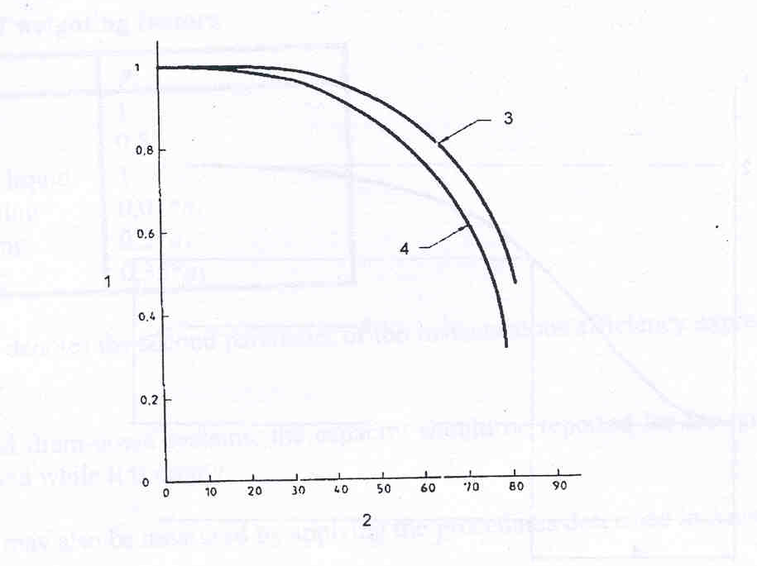

Right Figure 5

Comment 11: Illustrations
In Annex I the Figure I.3 is wrong figure and should be the one showed below.

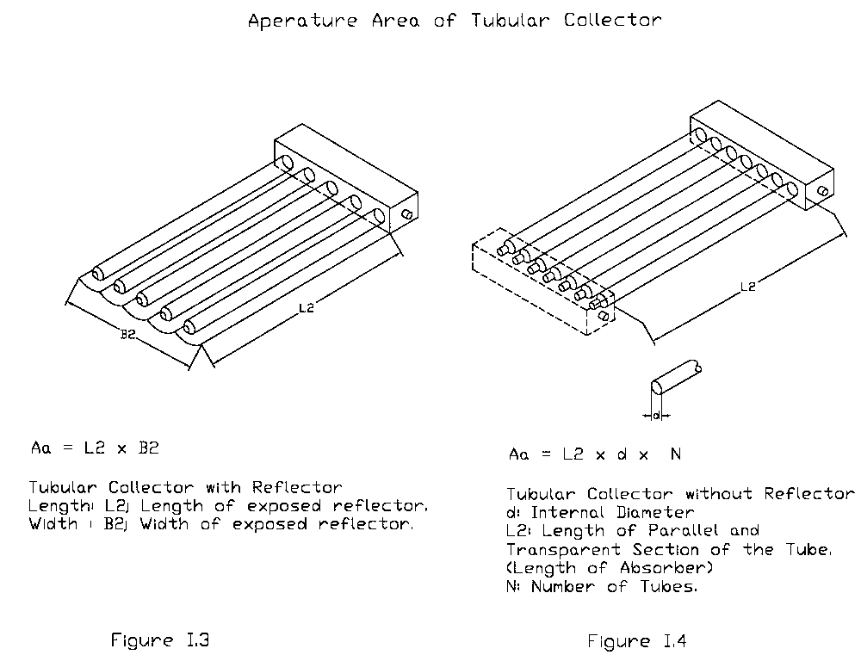

Right Figure I.3

Comment 12: Illustrations
In Annex I the Figure I.5 is wrong figure and should be the one showed below.

Right Figure I.5

Comment 11: Maximum Tm* values

In 6.1.4.4 it says that the maximum temperature shall be at least around 80 °C. This should be changed to “shall be chosen so that maximum Tm* value is at least 0.09 unless the temperature difference become smaller than required in 6.1.4.3.”

Comment 12: Choice of absorber test
Four different methods are described for heating the absorber in clauses 5.2.2.2.2 through 5.2.2.2.4. In Annex B.13.2.2, page 96, it should be written which method that has been used. It is not clear which method that should be used under certain conditions or if it is a free choice. Add at the end of 5.2.2.1 “One of the methods described in 5.2.2.2.2 through 5.2.2.2.4 may be chosen.

Comment 13: Clarification
Add at the end of 6.2.4.8.1 “NOTE: Positive EL values are a downward oriented irradiance onto a surface with a temperature of 0 K.

Comment 14: Delete per square meter two times

One can not calculate a value “per square meter” without knowing the reference area to use. Furthermore the effective thermal capacity of collector, C, has the unit (JK⁻¹) and the specific heat capacity, c_{i}, has the unit (Jkg⁻¹K⁻¹) according to page 5 and 6.2.6.2. Therefore, must the mass, m_{i}, in Equation 29 has the unit kg (that is in consistence with page 5). The sentence in 6.2.6.2 should be “… ,of the product of its mass, m_{i}, (expressed in kilograms), …”. Delete per square meter two times in 6.2.6.2.

Comment 15: Observation interval recommendations occurs with two expressions
In 6.1.2.1.1.3 it says that the condition for the desiccator should be observed both “prior to and following each daily measurement sequence” and “on a regular basis”. Delete “prior to and following each daily measurement sequence”.

Comment 16: Micrometers in Equation 14
The integration borders have wrong units. It should be micrometers expressed with the Greek “my” and a “m” (μm).

Comment 17: Change prEn to EN
Change to EN 12975-1 in Annex B.2.3 instead of prEN 12975-1.

Comment 18: Rain penetration test
The rain penetration test has been frequently discussed in the Solar Keymark meetings. The standard has three different methods for detecting rain penetration. It has been concluded that all three different methods are needed in the standard, but they need further specifications. Therefore, have Solar Keymark written three internal papers that address the difficulties and make suggestions how to clearer define all three methods. These papers are suggested to be the Solar Keymark recommendation for revision of the rain penetration test. The papers are added in the Annex 1-3 of this document.

ANNEX 1: Rain Penetration Test, Weighting the Collector

Comments and suggestions concerning the rain penetration test defined in 5.7 of EN 12975-2: 5.7.2.2.a: Weighting the Collector

Kostas Voropoulos
NCSR "Demokritos"

Point 1:

The Standard EN 12975-2 suggests three alternative methods of measuring the penetration of water into the collector, after the rain penetration test (5.7.2.2):

- weighting the collector
- humidity measurement
- measuring the condensation level

However, only for the first method it specifies the procedure and the measuring device together with its uncertainty. It says nothing about the other two methods, i.e. the procedure to be followed, instruments, accuracies, e.t.c.

The measurement of humidity inside the collector is a method which introduces many uncertainties due to its nature and it is not mentioned when, how and at which point of the collector this measurement is conducted.

The procedure for the measurement of the condensation level in the inside part of the cover is not also specified. Measuring the area of the condensate is very unreliable since this area does not have regular shapes and is not evenly distributed in the cover.

Our opinion is that the whole procedures for both humidity and condensation level measurements should be mentioned clearly in the test of paragraph 5.7 of EN 12975-2.

Point 2:

In 5.7.2.2 of EN 12975-2, it is stated that the minimum accuracy of scale must be + 1gr for the measurement of the collector weight.

Since there are collectors that their weight can reach over 50 kg, it is obvious that the measurement of such a collector with the accuracy of + 1 gr presents many uncertainties related to other environmental parameters and requires very expensive balances. It is proposed that the measurement should be conducted with an accuracy of 5 gr/m² collector area.

Point 3:

In the Standard there is no specific mention about the several types of collectors that can be tested in rain penetration, concerning their construction materials. However, there are collectors which have wood on their backs.

Our proposal is that an extra paragraph should be included in 5.7 of the Standard, stating clearly that in cases of collectors having wood in the backs (or other special cases), the laboratory must take all necessary measures so that the final result will not be influenced or altered by the special construction of the collector during the conduction of the test.

Comments and suggestions concerning the pass criteria of the rain penetration test defined in 5.3.7 of EN 12975-1

In this paragraph it is stated that the pass criterion for the collector concerning the rain penetration test, and in the case that the weighting method has been used, is that the determined water quantity shall be less than 5 gr/m².

According to our opinion, this figure is too small, since in praxis the majority of the collectors present such water penetration. It should also not be forgotten that actually this the only test in which a quantitative pass criterion is set, whereas in all other tests it is the "no major failure". This may cause the unhappy situation that a collector with medium efficiency can pass the rain penetration test due to its "heavy sealing", thus being certified and another collector with very high efficiency can be excluded because it did not meet the 5 gr/m² rain penetration criterion.

It is therefore proposed that the acceptance criterion of the rain penetration test for the collector should be 30 gr/m².

ANNEX 2: Rain Penetration Test, Humidity measurements

Comments and suggestions concerning the rain penetration test defined in 5.7 of EN 12975-2: 5.7.2.2.b: Humidity measurements

Christian Mûller-Schöll
SPF

As far as I see my job,we are looking for something quantitative, which
is still not very easily done, and might need some mor e experience and
also input from other labs, but I will try something that is on the safe
side:

******
For flat plate collectors, an "absolute humidity sensor" has to be
placed in the air gap between the absorber and the glazing. Care shall
be taken that the sensor does neither touch the glazing nor the
absorber. This type of sensor usually consistst of two elements, a
relative humidity sensor and a temperature sensor. Absolute humidity is
assessed by calculation. The collector and the sensor shall be connected
to the hot fluid loop for at least five hours before the rain is
switched on in order to stabilize. When testing outdoors, in order to
minimize disturbances of the measurement, the collector shall be shaded
during the whole test.

The humidity shall be monitored from five hours before the raining till
at least five hours after the raining.

Results
Any visuble droplets in the inside of the collector
or a humidity that exceeds 20 g/kg at any time during the periods
described above, or a humidity that doubles from the value measured
after stabilization during the periods described above, shall yield
"major failure" (a mark of "2").

NOTE: Ingress of water might also be detected at a later stage, during
the test "Final inspection", Clause 5.11.

Remarks from the author:
We might also need to add a chapter about humidity sensors,
calibrations, uncertainties etc. in the appropriate section.
Numerical figures in the text proposed above are subject to discussion.
******

ANNEX 3: Rain Penetration Test, Measuring of condensation level

Comments and suggestions concerning the rain penetration test defined in 5.7 of EN 12975-2: 5.7.2.2.c: Measuring of condensation level

Åsa Wahlström, Peter Kovacs and Roger Davidsson,

SP Swedish National Testing and Research Institute

The Standard EN 12975-2 suggests three alternative methods of measuring the penetration of water into the collector, after the rain penetration test (5.7.2.2):
- weighting the collector
- humidity measurement
- measuring the condensation level

This document gives a suggestion on how to clearer define how the test should be performed when using the measuring of condensation level for detection of ingress of water.

Improvements of test method

5.7.2.2
The collector shall be mounted and sprayed as explained above while the absorber in the collector should be kept warm (minimum 50 °C). The heating of the collector shall be started at least 30 minutes before the spraying of water to ensure that the collector box is dry before testing. This shall be done by circulating hot water (or other transfer fluid) above 50 °C through the absorber before but also during the complete test. The option of keeping the absorber warm by exposing the collector to solar radiation are, therefore, not suitable for detection of ingress of water by measuring the condensation level.

For the entire time that the test is in progress the absorber is kept warm and this will evaporate the water that finds its way into the collector. The water will thereafter condense on the inside of the glazing, which is being cooled by cold water on the outside. To ensure that no water has penetrated the collector box without forming condensation on the glazing, the collector shall be tipped on all four sides in turn after the test is terminated.

The penetration of water into the collector shall be determined by measuring the condensation level on the cover glass and by measuring the water that come out of the collector when tipping it.

5.7.3
The collector should be sprayed with water at a temperature between 10-25 °C and with a flow rate of approximately 0,05 kg/s per square meter of sprayed area. The duration of the spraying shall be 4 hours.

After 2 hours an intermediate inspection of condensation of the cover glass shall be done in order to facilitate the reporting of the places where water penetrates. After finishing the spraying the inspection of condensation of the cover glass should be done immediately, before the collector will make any temperatures changes. The collector shall not be exposed by solar radiation. The condensation area on the glazing shall be measured.

On completion of the measuring the condensation level, dry the collector carefully on all sides. Tip it on to all four sides in turn, standing it on a clean base on which any water that runs out can be collected and/or approximated quantified.

5.7.4
The collector should be inspected for water penetration by the presence of any condensation and the approximate quantity of water that leaked out. The results of the inspection i.e. the extension of water penetration and the places where water penetrated shall be reported.

EN 12975-1

5.3.7
c) the measured condensation level shall be less than 5 % of the transparent cover and the collected water shall be less than 20 gr/m².



Secretariat: | Nederlands Normalisatie-instituut |  |  | . | doc.nr
 | Vlinderweg 6 | P.O. Box 5059 |  | CEN/TC 312/WG2 | N124
 | 2623 AX Delft, | 2600 GB Delft, NL |  | date  2002-10-08 | total pages:  7
 | The Netherlands | The Netherlands |  | date  2002-10-08 | total pages:  7
 | telephone: | +31 15 2 690 338 |  | date  2002-10-08 | total pages:  7
 | fax: | +31 15 2 690 688 |  | Committee | CEN/TC 312/WG2
 | E-mail: | Jeannette.hofman@nen.nl |  |  | Factory made solar systems

Comments to EN 12976-1 and –2 , source “Solar Keymark” consortium
Proposals from WG 2 convenor

A. General Comments
Nr. | Reference | From | Comments | Proposal WG2 Convenor | Room for notes
G.1 | EN 12976-1  4.1.1 + 4.1.2 | TNO/SK | - prEN → EN, undated  - There are doubts about the suitability of these standards | EN 1717 and EN 806-1 are important standards for SDHW systems. These standards will be subject to European directives in the near future and could therefore remain in this standard.
G.2 | EN 12976-1  4.1.4  EN 12976-2  5.1 + 5.9 | SK | ISO/DIS 11924 and ISO/DIS 9459-5 are removed from ISO program | CEN TC 312 Resolution “publish as EN standard with UAP procedure”.  In the mean time electronic versions of FDIS file are available.  ISO/DIS 9459-5 is also available as Annex in Dutch standard. (NPR 7976)

G.3 | EN 12976-1  4.1.1  4.1.4.2  and other | SK/Democritos | There are a few qualitative requirements with no clear pass/fail. | These requirements are in standard in order to give some general guidelines. These types of requirements could be changed into recommendations (change “shall” into “should”. If tester finds general deviations this shall be reported.
G.4 | 4.3.6 | TNO | Standard prEN 12897 (vessels) suffered from decreasing interest in the market and is likely not to be published as an EN. Referring to this standard is therefore not suitable. | Option 1: adopt clauses from prEN 12987 into EN 12976  Option 2: refer to other standard (proposal NEN during meeting)
G.5 | All tests EN 12976-2 | SK/Democritos | Uncertainty calculations should be available | Option 1: Adopt procedures within EN 12976  Option 2: Define more uncertainty bands within EN 12976 and leave general uncertainty calculations up to certification and accreditation procedures.
G.6 | Chapter 4 | INETI | There should be a required test sequence | Depending decisions within certification consortium, parallel testing and “single testing allowed for product families” may be in force. Within this respect a strict test sequence is disputable.
G.7 | EN 12976-2 5.9 | TNO | Parasitic energy use does not include electrical freeze protection | Adopt requirement that supplier should report parasitic energy use of special anti freeze equipment (if present).

B. Editorial comments
Nr. | Reference | From | Comments | Proposal WG2 Convenor | Room for notes
E.1 | EN 12976-1  4.3.7 | TNO | Reference to “prEN 12975:2000” should be “ EN 12975-2, 5.3” | Adopt and correct
E.2 | Chapter 4 | TNO | Numbering odd and some “hanging paragraph” | Correct during revision, check references throughout document and report to WG1 and WG3.
E.3 | Reference to ISO/DIS 11924 and ISO/DIS 9459-5 | TC 312 | ISO/DIS 11924 and ISO/DIS 9459-5 skipped from ISO program | As ISO/DIS 11924 and ISO/DIS 9459-5 will be published as EN’s the references within EN 12976 should be changed accordingly
E.4 | EN 12976-1, 4.8 | SK | Wrong reference in EN 12976-1 page 13, ”5.10” should be ”5.9” | Correct

C. Technical Comments
Nr. | Reference | From | Comments | Proposal WG2 Convenor | Room for notes
T.1 | 4.1.3.2  EN 12975-1 | TNO | It should be checked whether pump is controlled correctly. | Check control according to 5.1.5, EN 12976-2
T.2 | 4.1.4  EN 12976-1 | TNO | In case of drainback: system should be checked for correct drain back during overtemperature. | Adopt that drain back shall be checked in accordance with 5.1 EN 12976-2.  What about other system types?
T.3 | 5.2  EN 12976-2 |  | Too much unnecessary explaining and requirements here not in place | Dense text, remove requirements to related parts in EN 12976-1

T.4 | 4.3.2  EN 12976-1 | TNO BCR | Not in accordance with present situation within Eurocodes. | Replace by:  - Manufacturer shall state the maximum possible loads for their supporting frame, in accordance with EN 1993 (Steel) and EN 1999 (Aluminum)  - This shall be mentioned in the documents for the installer  - Allowance of installing the system is depending on national requirements. Guidelines can be found in new Eurocodes for wind and snowloads.
T.5 | 4.1.4.1  EN 12976-1 | TNO | Maximum of 60⁰C is too strict in practice. | A gap of 5º C should be allowed in practice (so max T 65º)
T.6 | 5.9  EN 12976-2 | IZES | DST is not recommended for load site heat exchanger and temperature controlled pump  (see also SMT project“bridging the gap“) | This should mentioned in 5.9 EN 12976-2
T.7 | 5.9  EN 12976-2 | CSTB | Mains water temperature (ISO/DIS 9459-5:1997 clause 6.2.2.1.1). According to the standard, the upper limit of the mains water temperature is 20 °C. This limit cannot be respected in summer without cooling. If it has no physical justification we proposed to raise this limit up to 25 °C. | This is not in accordance with the scientific base of ISO/DIS 9459-5:1997. Cooling is required in this case.

T.8 | 5.9  EN 12976-2 | CSTB | Air velocity (ISO/DIS 9459-5:1997 clause 5.2.3.6) "the surrounding air velocity shall be measured on a surface (minimum dimensions 1m x 1m) fixed in the same plane as the collector surface." In this case, a three-cup anemometer could not met the specifications (+/-0.5ms-1). What is the solution? | To be discussed during meeting
T.9 | Annex B | Democritos | Reference conditions for determination of long-term energy output of a system tested by the CSTG Method (EN 12976-2) are not correct. | Adopt reference conditions as established within SMT project bridging the Gap (see proposal A underneath)
T.10 | Annex B | CSTB | Daily load pattern (Annex B Reference conditions for performance prediction). The pattern 100 % after solar noon favors the ICS systems (little effect of night losses). It is a problem for us when we assess thermosiphon and ICS for Corsica or overseas territories. | This could be resolved if other load patterns are allowed for CSTG LTPP calculations.  To be discussed during meeting

Proposal A: Adopt reference conditions for CSTG methods according to reference conditions established with the SMT project “Bridging the Gap”.
Deviation to LTPP calculation ISO 9459-2 (CSTG)

For calculating LTPP with CSTG results reference conditions of Annex B in En12976-2 will be used. With exception of the following:
- the LTPP of CSTG test method follows Load Pattern 3, see underneath.
- if the information available on the collector IAM corresponds to Ambrosetti equation with r > 0.4, the parameter identification in the CSTG test method should be done considering the daily radiation values corrected for the IAM effect.

Load pattern 3: Load determined by maximum energy needed.

This load pattern is in agreement with DST calculation procedure and also with the Reference conditions of prEN 12976-2 (1997) – Annex B.
In ref. [4] the necessary changes in ISO 9459-2 for the calculation procedure to be in agreement with reference conditions and DST calculation is presented and reproduced here:

Changes in point 9 of ISO 9459-2 (pages 21, 22, 23 and 24), Step3 (Energy drawn off):

- Calculations for Day 1:

Q_{c}(1) is calculated according to:
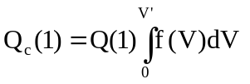
where V’ is determined by two conditions:

- Calculations for Day 2 and subsequent days:

Q_{c}(2:part1) is calculated according to:
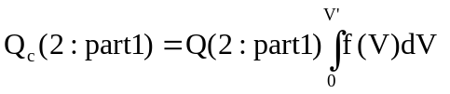
and Q_{c}(2:part2) is calculated according to:
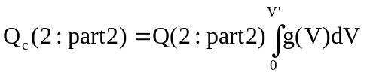
The value V’ is determined when the total energy extracted is calculated according to:

The calculations done according to this procedure give lower values than with one load volume extracted every day, but will give higher values than with the consideration of a minimum load temperature.

Comments to ENV 12977 series from Solar Keymark project WP1.C and CEN TC312/WG3

Jan Erik Nielsen, 30/10 2002

At the combined Solar Keymark WP1.C / CEN/WG3 meeting in Rome, October 2002, there was a fundamental discussion about the future for the ENV 12977 standard series.

The reason for this fundamental discussion was the lack of interest amongst the involved test labs and industry. And the lack of interest should be sought in the facts that:
- ENV’s are not subject to Keymark certification
- so far the systems and components handled in the ENV 12977 standards are not very standardized in Europe and do not – so far – cross the borders in big numbers
- limited resources for developing the ENV’s into EN’s

The outcome of the discussion was to concentrate on the standard for thermal performance of stores – ENV 12977-3, and to try as quickly as possible to turn this ENV into an EN (to make Keymarking possible). To do this it is proposed to simplify the standard by deleting one of the two test methods now included, and then focus on making the other method – described in “6.3.2 Determination of store parameters by means of parameter identification” - as operational and simple as possible.

This fundamental proposal will be brought forward to the CEN/TC 312 meeting in March 2003 by the WG3 convenor, and after approval work will start.

